FACTORIAL OF THE NUMBER:

Create or replace function factorial(

Num int

)

Return varchar2

Is

Fact:=1;

Begin

For i in 1….n loop

Fact:=Fact\*i;

End loop;

Return fact

End;

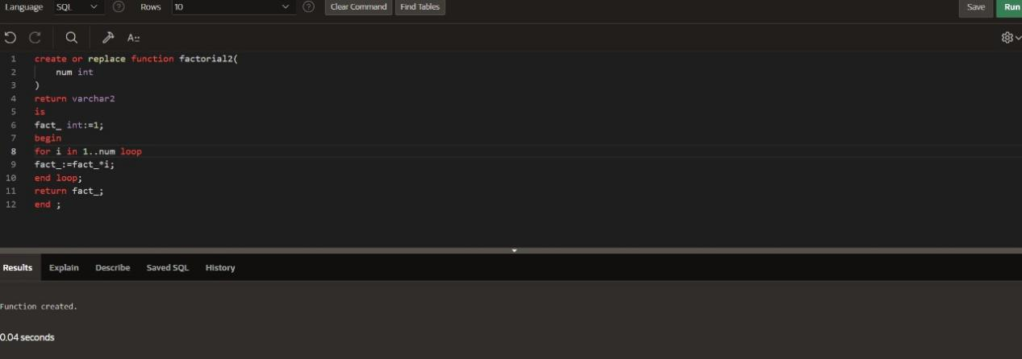

Select factorial(10) from dual;

